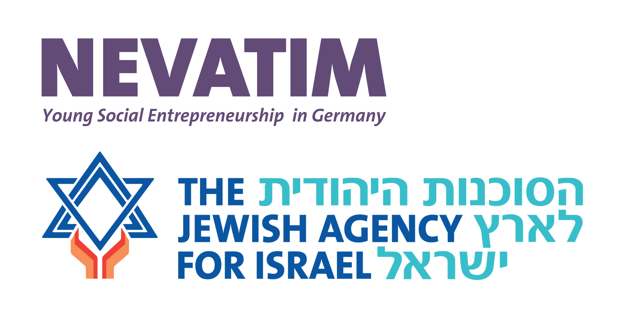

**Application for project funding Nevatim 2025**

| 1. Title of the project |
| --- |

| 2. Information on the applicant |
| --- |

1. Please enter all current contact persons, contact details and function

(at least 3 contact persons with e-mail addresses and telephone numbers).

Please send us **a tabular CV of the 3 applicants**, including a description of their relevant experience if applicable.

1. If available, details of partner organizations, cooperation
2. Institutional connection: Name of the organization (incl. head of the organization) and bank details of the payee

| 3. Project description. |
| --- |

1. Pitch your idea! Describe your project in three to a maximum of five sentences.
2. Where does your project take place? What is the geographical scope of your project?
3. What motivated you to come up with the project idea? Explain your personal motivation for the project.
4. Project idea, brief content concept.

What is the initial situation and the current status and which problem should the project explicitly address?

1. What do you want to achieve with the project? Describe the project goals.
2. What challenges may arise during your project? Please explain what you and your team plan to do to mitigate these risks?
3. Who is the project aimed at? Describe your target group.
4. Project period (project start and end date)*

* *The project can start no earlier than November 2025 and must be completed by December 31, 2026 at the latest.*

1. What educational content should be conveyed in educational projects? (if relevant)
2. Does the project address the following topics? Gender-based violence, mental health/psychosocial services, economic inclusion, legal protection? (if applicable, please explain)

1. Planned speakers, personnel if applicable

1. Planned public relations work* (advertising, press work, etc.)

*Regular submission of photo and video materials during the project period is required to support and enhance our public relations efforts.

1. Outreach! How many people do you want to reach?
2. How do you want to evaluate your project? (e.g. feedback round, evaluation form)
3. What criteria do you use to monitor success in the project?
4. Schedule

Please provide a provisional timetable for the course of the project. e.g.:

| Date | Activity name/topic | Activity description | Planned number of participants |
| --- | --- | --- | --- |
|  |  |  |  |

| 4. Financial information |
| --- |
| **\*The maximum amount of the grant from Nevatim is 10,000 euros.**  **Fee costs, material costs, printing costs, travel costs (2nd class only), accommodation costs are eligible for funding. All items must be itemized.**  **The expense allowances for the project team may not exceed 10% of the grant applied for.** |

| **Expected expenditure** | **Euro** |
| --- | --- |
| Fee costs/expense allowance |  |
| 1. |  |
| 2. |  |
| 3. |  |
| Material costs (materials, printing costs, food costs, other) |  |
| 1. |  |
| 2. |  |
| 3. |  |
| Travel costs |  |
| 1. |  |
| 2. |  |
| 3. |  |
| Accommodation costs  1. |  |
| 2. |  |
| **3.** |  |
| **Other (room rental, transportation costs, admission costs, contribution costs, administrative costs – please provide a breakdown by category)** |  |
| 1. |  |
| 2. |  |
| **Total** |  |

| **Expected income** | **Euro** |
| --- | --- |
| Own funds of the project sponsor |  |
| Participant contributions |  |
| Donations |  |
| Scope of the financing requested from Nevatim |  |
| **Total** |  |

| 5. Networking |
| --- |

The Nevatim funding program consists of both financial and non-financial (ideational) support.  
 The project team is required to participate in two seminars and one conference during the funding period (until December 31, 2026):

* **November 7–9, 2025:** Nevatim Conference (Leipzig)
* **2026:** 1st Nevatim Seminar (tba)
* **2026:** 2nd Nevatim Seminar (tba)

Are you willing to participate in the seminars and the conference of the Nevatim program?

**YES / NO**

| *Location, Date* | *Name, Signature of the applicant* |
| --- | --- |
|  |  |

Appendix: Tabular CVs of the initiative group (at least 3)

01.08.2025

NEVATIM funding program

The competition conditions and project requirements.

1. **What is supported?**

Nevatim is a funding program of the Jewish Agency for Israel and supports educational initiatives aimed at **awakening and developing Jewish self-confidence** among **Jewish youth**, **students** and **young families**, strengthening the **Jewish community** in Europe and strengthening the **connection to Israel.**

Nevatim primarily accepts applications for funding for non-commercial projects in the following areas:

* Projects in the field of informal Jewish education for Jewish young adults, students and academics
* Jewish educational programs for children and families
* Projects with an educational or socio-cultural focus
* Projects dedicated to building the Jewish community

Other areas of activity are eligible for funding in justified cases.

**Ensuring that the project measures are created and implemented within the total funding period is very important to the Nevatim program. Events lasting one or more days are not supported.**

1. **Who can apply for funding?**

Funding is available for **local initiative groups whose** activities focus on Jewish education. It is not possible to support existing Jewish organizations as a whole; only **specific individual initiatives** are eligible for funding. The **initiative groups must consist of at least three people**.

Eligible to apply are persons who are considered Jewish in accordance with the Law of Return of the State of Israel, who are not under **18 and not over 35 years of age at the** time of application and whose main place of residence is in the European Union.

The **project's target group** is not subject to these restrictions.

Funding is available for projects by independent initiative groups, but these must be carried out by a non-commercial organization, i.e. a legal entity.

Possible sponsors for the projects are:

* Registered associations (e.V.)
* Corporations under public law (municipalities)
* Municipal youth facilities

If approved, the funding will be paid into the sponsor's association account.

The organization receiving the grant can be any local organization that operates legally in the European Union and does not contradict the general principles of democratic Jewish education.

The organization must agree to these guidelines in writing and countersign the final report to be submitted by the project manager. If no partner organization can be found, Nevatim can provide support.

Projects already funded by Nevatim can apply for an extension for a further funding year.

The initiative groups that have already received grants from Nevatim can apply with new project ideas at any time.

**3. scope of funding and co-financing**

Nevatim offers grants of up to 10,000 euros per project and funding year. The support of the Jewish Agency for Israel should play a decisive role in the realization of the projects. As a rule, co-financing of larger projects is not possible. In justified exceptional cases, this may be deviated from; the decision on this is the responsibility of the funding committee. If the initiative group/organization has an additional source of funding for the project, this and the amount of funding must be disclosed to Nevatim.

**4. further conditions for funding**

Nevatim's support is not limited to financial support, but also includes meetings and seminars for the purpose of exchange. Regular participation in these events is expected of the sponsored persons. All events and publications of the projects must refer to the funding by Nevatim using the logo of the Jewish Agency. The logo of the Jewish Agency must account for at least 50% of the total space used for logos. Deviations from these rules will result in the termination of funding and the reclaiming of all payments made to date by Nevatim. Nevatim must be notified of all events for publication in the newsletter so that they can also be made known to other project managers and participants in the interests of the network. Furthermore, after each event, short reports with comments from the participants as well as photos are to be sent to Nevatim, which can then also be distributed in the newsletter.

**5. application procedure**

The funding committee sets an annual deadline by which projects can be submitted for funding. The funding committee meets regularly to decide on the applications submitted. Applications received after the application deadline cannot be considered. The date of receipt counts. The application for funding must be sent to Nevatim by e-mail. The application should contain all the information requested in the points in a binding manner.

Applications must always be submitted in German or English. Applications written in other languages can also be submitted by arrangement.

**6. report**

Nevatim must be informed immediately of any changes to the project schedule and budget.

An organization that has received a grant is obliged to submit a report on the work carried out and a financial report in the form specified in the contract no later than four weeks after the end of each project year. This includes a table of income and expenditure and a questionnaire which must be completed and returned; both documents are provided by Nevatim. In addition, all related advertising materials, photos and, if applicable, copies of media reports must be enclosed. The Jewish Agency reserves the right to carry out a detailed review of individual projects up to and including three years after the end of the project. All original receipts, receipts etc. must therefore be kept for three years after the end of the project.